DISNEY KINDERGARTEN AND PRIMARY SCHOOL

LESSON NOTES FOR LITERACY, P.1 SECOND TERM 2020 TOPICAL BREAKDOWN

WEATHER
- Elements of weather
- Types of weather
- Management of different types of weather
- Activities done in different types of weather

ACCIDENTS AND SAFETY
- Common accidents
- Causes of accidents
- How to control accidents
- Effects of accidents
- First aid
- Reasons for giving first aid
- Road signs
- Traffic lights

LIVING TOGETHER
- Family- meaning of family
- Types of families i.e.
- Nuclear family
- Extended family
- Ways of living together at home
- School activities
- School rules- Examples of school rules / Disney rules and regulations
- School routine- Examples of school routines
- Ways of living together in a community
- Basic needs of people in a community

FOOD AND NUTRITION
- Meaning of food
- Examples of food
- Classes of food
- Sources of food
- Why we eat food
- Food preservation

LESSON 1
Learn these spellings and test yourself.
- Rain
- Sun
- Clouds
- Wind
- Weather
READ, COPY, AND DO THE EXERCISE GIVEN IN YOUR EXERCISE BOOK FOR EVERY LESSON.
Copy and write these letters correctly.
l , l l l l l l l l l l
____________________________________________________________________
i i i i i i i i i i i i i
____________________________________________________________________
WEATHER
- Weather is the state of atmosphere at a given time in a given place.

ELEMENTS OF WEATHER
Elements of weather are the things which make weather to change. They include:

- Sunshine
- Wind
- Rainfall
- Cloud cover
Exercise
1. What is weather?
2. List any two elements of weather.
3. Name these elements of weather.

 | 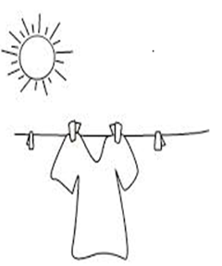 | 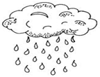 | 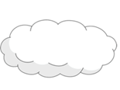

3……………… is the state of atmosphere at a given time.

LESSON 2
Spelling work
- Rainy
- Cloudy
- Windy
- Sunny
Copy and write these letters correctly.
V V V V V V V V V V V
____________________________________________________________________
v v v v v v v v v v v
____________________________________________________________________
TYPES OF WEATHER:

- sunny
- rainy
- windy
- cloudy

Exercise
1. What is weather?
2. Name these types of weather.

- Match correctly
Sunshine windy
Clouds rainy
Rainfall sunny
Wind cloudy

LESSON 3
Spelling work
- Famine
- Sweat
- Animals
- Heat
Copy and write these letters correctly.
W W W W W W W W W W ____________________________________________________________________
w w w w w w w w w w ____________________________________________________________________
USES OF ELEMENTS OF WEATHER AND THEIR DANGERS
1. Sun shine
Uses of the sun
- The sun gives us light and heat
- Sunshine helps our plants to grow well
- Sunshine helps our washed clothes to dry
- Sun shine dries our harvested crops e.g. beans, Millet, maize, etc.

Dangers and effects of too much sunshine

- It dries the sources of water
- It dries our plants

- It causes famine
- It makes us sweat

- It kills our animals
Exercise
- List any two dangers of too much sunshine.
- The ………………………gives us heat and light.
- How is useful is the sun to people?
- Which type of weather dries our crops?
- How is too much sunshine dangerous to people?

LESSON 4
Spellings
- Water
- Plants
- Floods
- Slides
Copy and write these letters correctly.
Z Z Z Z Z Z Z ____________________________________________________________________
z z z z z z z ____________________________________________________________________
2. RAIN
Uses of rain:
- Rain gives us water
- Rain helps our plants to grow well
Dangers and effects of too much rain:

- It kills people and animals
- It spoils our plants
- It brings floods
- It spoils our roads
- It can break our houses
- It causes late coming
- It carries away our good soil
- It brings slides

Exercise
1. Mention any two uses of the sun.
2. Name this element of weather.

3. Which vitamin is made by the skin using sunlight?
……………………………………………………………………………………..
4. Where does rain come from?
5. List any two dangers of too much rain.
6. What does too much rain cause?

LESSON 5
Spelling work
- Destroy
- Soil erosion
- Winnowing
- Diseases
Copy and write these letters correctly.
X X X X X X X X X X X X X ____________________________________________________________________
x x x x x x x x x x x x x ____________________________________________________________________
WIND
- Wind is the moving air.
Uses of wind
- It helps us to light charcoal stoves
- It helps kites to fly
- It helps farmers to winnow their seeds
- It helps our wet clothes to dry
Dangers and effects of too much wind:
- Strong wind destroys plants
- Strong wind destroys houses
- Strong wind rises up dust
- It causes soil erosion
- Wind can spread some diseases like flu and cough etc.
Exercise
1 What is wind?
2 Name any two uses of wind.

3 Name this type of weather.
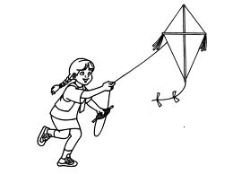

4. Mention any two dangers of too much wind?
5. Name any one disease spread by wind.
6. How dangerous is wind to farmers
7. List any two activities done during windy weather.

LESSON 6
Spelling work
- Planting
- Harvesting
- Drying seeds
- Watering

Copy and write these letters correctly.
O O O O O O O O O O O O O ____________________________________________________________________
o o o o o o o o o o o o o ____________________________________________________________________
TYPES OF SEASONS
- Wet season
It is the period when a place receives rain for a long period of time.

- Dry season
Dry season is the period when a place receives sunshine for a long period of time.

Activities done during the wet season
- Planting
- Weeding
- Pruning
- Thinning
- transplanting
Activities done in the dry season
- preparing land
- Watering plants
- Clearing the bush.
- Harvesting crops
- Drying seeds
- Sorting seeds for planting
- Mulching
- harvesting

Exercise
- Name any one activity done in the wet season.
- Name these activities people do in the garden
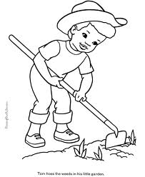

3. Name the two seasons we have in the year.
4. List any two activities done in the dry season

LESSON 7
Spelling Work
- Splitting
- Slashing
- Manure
- Rubbish
- Peeling
- Harvesting

Copy and write these letters correctly.
C C C C C C C C C C C C ____________________________________________________________________
c c c c c c c c c c c c ____________________________________________________________________
GARDEN TOOLS
hoe | rake | knife | basket | wheelbarrow
axe | slasher | panga | trowel | Watering can
Uses of garden tools

- Axe – cutting big trees and splitting wood.
- Hoe – digging.
- Slasher – slashing the grass.

- Wheelbarrow – carrying food, rubbish and manure.
- Rake – collecting weeds.
- Spade – collecting rubbish and manure.
- Panga - cutting small trees.
- Knife – peeling and harvesting.
- Basket – carrying harvested food.
- Watering can – watering the crops.
- Garden trowel-for transplanting seedlings.

Exercise
- Name these garden tools.
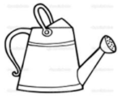 | 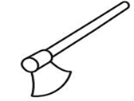 | 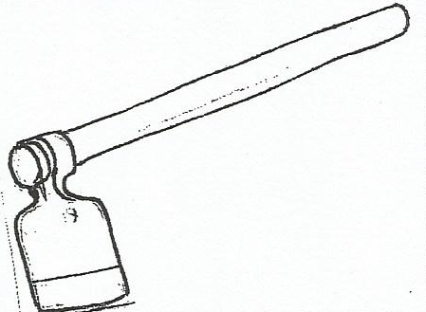 | 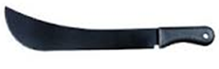
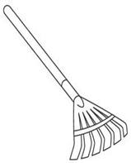  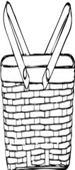 |  | 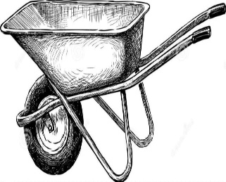 | 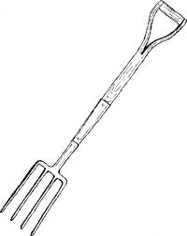

- Match the following;
Tool use
Hoe cutting big trees
Panga collecting rubbish
Rake digging

- Complete the table below
Picture | Its name | Importance
 | _________________ | For cutting big trees
 | rake | For collecting rubbish
 | Watering can | _____________
_________________________ | ____________________ | For cutting small trees

LESSON 8
Spelling work
- Ponds
- Wells
- Lakes
- Rivers
- Taps
- Tank
- Streams
Copy and write these letters correctly.
A A A A A A A A A A A A A ____________________________________________________________________
a a a a a a a a a a a a a ____________________________________________________________________
SOURCES OF WATER.

- Rain
- Wells
- Rivers
- Lakes
- Streams
- Ponds
- Taps
- tanks

HOW TO MANAGE RAINY WEATHER

Things we use to protect ourselves from rainy weather
During rainy weather we use
- sweaters
- rain coats
- Umbrellas
- gumboots
- jackets
- sweater

EXERCISE
- Name these things we use on the rainy weather.

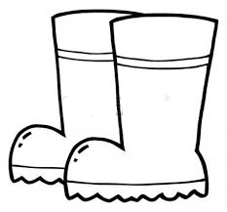 | 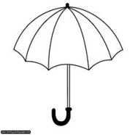

2. Where does rain come from?
3. Name this type of weather.

4. Where do people in different homes get water from?
5. Which type of clouds give us rain
6. Why do we need water?
LESSON 9
Spelling work
- Mulch
- Protect
- Harvest
- Clothes
- Plant
- Protect
- soil
Copy and write these letters correctly.
E E E E E E E E E E E E E ____________________________________________________________________
e e e e e e e e e e e e e ____________________________________________________________________
HOW TO MANAGE SUNNY WEATHER
- We can mulch our plants to keep water in the soil
- We can water the plants to protect them from drying.
- We can wear light clothes
- We can use umbrella

THINGS WE USE TO PROTECT OURSELVES FROM SUNNY WEATHER
- sunglasses
- vests
- umbrella
- light clothes
- hats
- caps
Exercise
- Name these things we use during sunny weather.

 |  | 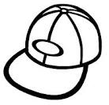
 | 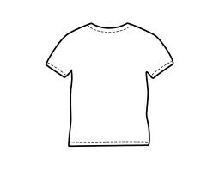 | 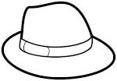

- How do we manage the sunny weather?
- How useful is sunshine in our bodies

LESSON 10
Spelling work
- Wear
- Warm
- Materials
- Cloudy
- Weather
Copy and write these letters correctly.
M M M M M M M M M M M M M ____________________________________________________________________
m m m m m m m m m m m m m ____________________________________________________________________
HOW TO MANAGE CLOUDY WEATHER
- We can wear coats sweaters and jackets
- We can warm ourselves
- We can put on scarves

HOW TO MANAGE WINDY WEATHER.
- We can plant trees
- We can build houses using strong materials.

Exercise
- Write two ways people manage cloudy weather.
- How can people manage windy weather?
- What can happen to our houses if we don’t plant tree in front in our compounds?
- How dangerous is wind to farmers?
5. Draw windy type of weather.

